Tertiary Infotech Academy Pte Ltd
UEN: 201200696W


LESSON PLAN
For

Microsoft Azure Fundamentals (AZ-900)
TGS Ref No: TGS-2023036449
Conducted by
Tertiary Infotech Academy Pte Ltd
UEN: 201200696W
Version 1

Document Version Control Record
Version Number | Effective Date of Release | Summary of Included Changes | Author
1 | 8 July 2026 | First Azure AZ-900 courseware build aligned to all 16 hands-on labs. | Tertiary Infotech Academy Pte Ltd

Course Details
Course Title | Microsoft Azure Fundamentals (AZ-900)
TGS Ref No. | TGS-2023036449
Duration | 2 Days (16 training hours)
Training Hours | 9:00 AM - 6:00 PM, including lunch and short breaks
Delivery Mode | Instructor-led classroom training with Azure hands-on labs
Learning Platform | Azure Portal, Azure Cloud Shell, Microsoft Learn and Google Classroom
Assessment | Written assessment, practice questions and hands-on lab participation
Learner Guide | LG-Microsoft Azure Fundamentals (AZ-900).docx
Slide Deck | Microsoft Azure Fundamentals (AZ-900)-v1.pptx
Lab Source | labs/ folder, 16 markdown labs
Primary Resource Group | rg-az900-labs
Region Used | Southeast Asia

Note: The 'Slides' column in each schedule table references the exact slide numbers in the Learner Guide Slides deck for that activity.

Course Overview
This 2-day hands-on course introduces Microsoft Azure fundamentals through guided portal, Cloud Shell and governance labs. Learners create core Azure resources, inspect common service settings, and apply basic identity, access, policy, cost and monitoring controls.

Learning Outcomes
By the end of this course, participants will be able to:
- Describe core cloud concepts, Azure regions, availability zones and Azure management tools.
- Create and inspect Azure compute, application, container, network, storage and database services.
- Explain Microsoft Entra ID, users, groups and role-based access control.
- Apply resource governance using tags, locks, Azure Policy, budgets, Advisor, Service Health and Azure Monitor.

Delivery Diagram - Course Flow
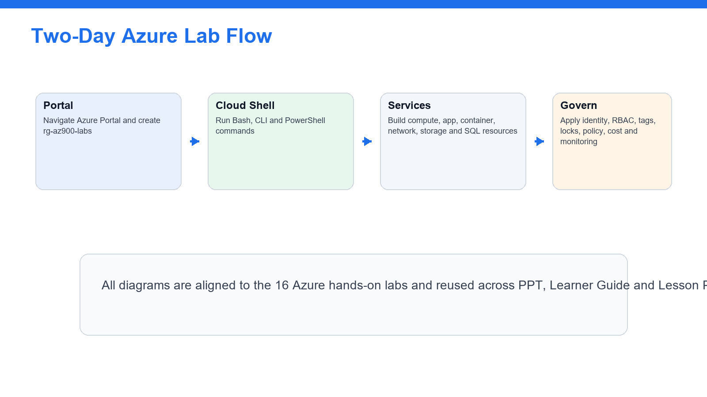
Trainer view of the two-day flow and the order in which learners encounter the labs.

Delivery Diagram - Governance Emphasis
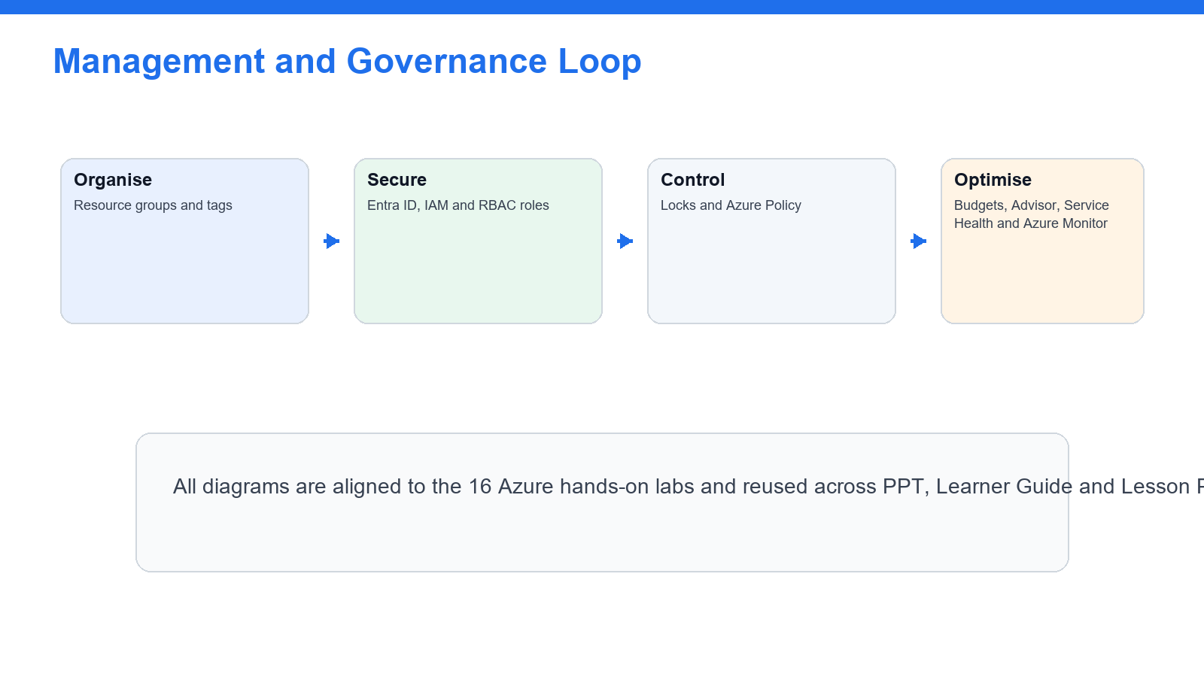
Day 2 emphasises management and governance concepts tested in AZ-900.

Delivery Diagram - Domain Weight Matrix
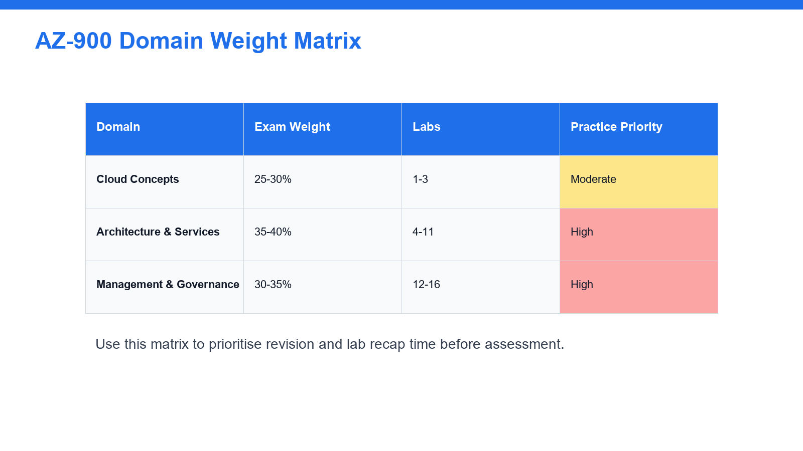
The schedule gives the highest practice weight to the largest AZ-900 domains.

Day 1
Topic 1: Cloud concepts, Azure portal, Cloud Shell and core architecture
Morning Session - 9:00 AM - 1:00 PM
Time | Activity / Topic | Slides | Duration
9:00-9:30 | Welcome, trainer introduction, ground rules, attendance and course objectives | 1-13 | 30 min
9:30-10:25 | Lab 1: Tour the Azure Portal and create the first resource group | 21-23 | 55 min
10:25-10:40 | Tea Break | - | 15 min
10:40-11:30 | Lab 2: Get started with Azure Cloud Shell | 24-26 | 50 min
11:30-12:30 | Lab 3: Regions, region pairs and availability zones | 27-29 | 60 min
12:30-1:00 | Review: AZ-900 domain matrix and shared responsibility model | 19-20 | 30 min

Afternoon Session - 2:00 PM - 6:00 PM
Time | Activity / Topic | Slides | Duration
2:00-2:50 | Lab 4: Create a Windows virtual machine in the portal | 30-32 | 50 min
2:50-3:35 | Lab 5: Create a Linux VM with Azure CLI | 33-35 | 45 min
3:35-3:50 | Tea Break | - | 15 min
3:50-4:35 | Lab 6: Create a Web App with Azure App Service | 36-38 | 45 min
4:35-5:15 | Lab 7: Deploy a container with Azure Container Instances | 39-41 | 40 min
5:15-6:00 | Lab 8: Create a virtual network and test private connectivity | 42-44 | 45 min

Day 2
Topic 2: Azure services, identity, governance, cost management and monitoring
Morning Session - 9:00 AM - 1:00 PM
Time | Activity / Topic | Slides | Duration
9:00-9:45 | Lab 9: Create a storage account and work with blob storage | 45-47 | 45 min
9:45-10:30 | Lab 10: Create an Azure SQL database | 48-50 | 45 min
10:30-10:45 | Tea Break | - | 15 min
10:45-11:35 | Lab 11: Explore Microsoft Entra ID users and groups | 51-53 | 50 min
11:35-12:25 | Lab 12: Manage access with Azure RBAC | 54-56 | 50 min
12:25-1:00 | Q&A and recap: identity and access | 51-56 | 35 min

Afternoon Session - 2:00 PM - 6:00 PM
Time | Activity / Topic | Slides | Duration
2:00-2:40 | Lab 13: Apply resource tags and resource locks | 57-59 | 40 min
2:40-3:25 | Lab 14: Enforce standards with Azure Policy | 60-62 | 45 min
3:25-3:40 | Tea Break | - | 15 min
3:40-4:25 | Lab 15: Estimate and control costs | 63-65 | 45 min
4:25-5:15 | Lab 16: Advisor, Service Health, Azure Monitor and final cleanup | 66-68 | 50 min
5:15-6:00 | Practice exam briefing, assessment flow reminder and course close | 10-11 | 45 min

Tools, Accounts & Resources
Resource | Purpose | Notes
Azure free account | Create and manage lab resources | Use a subscription with permissions to create resources.
Azure Portal | Portal-based labs | https://portal.azure.com
Azure Cloud Shell | CLI and PowerShell labs | https://shell.azure.com
Google Classroom | Practice exam and class resources | Use the class link provided by trainer.

Assessment
- Learners complete hands-on labs and practice questions during the course.
- Assessment flow: TRAQOM attendance, assessment attendance, written assessment, LMS submission and assessment record signing.
- Learners should revise weak areas using the AZ-900 domain matrix and practice exam slide.

